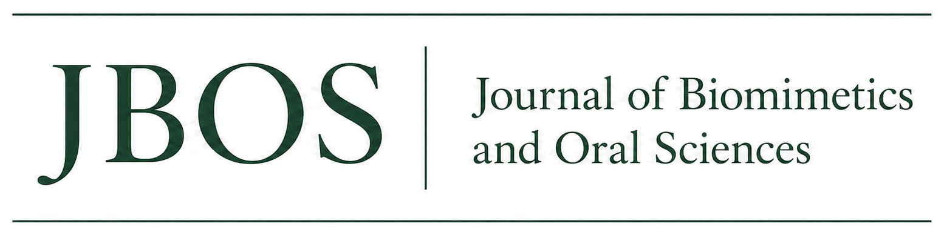

Type of Paper: Type of the Paper (Article, Review, Communication, etc.)

TITLE OF THE MANUSCRIPT
[LEAVE BLANK FOR BLIND REVIEW: AUTHOR NAMES]
¹ [LEAVE BLANK FOR BLIND REVIEW: AFFILIATION 1]
² [LEAVE BLANK FOR BLIND REVIEW: AFFILIATION 2]
³ [LEAVE BLANK FOR BLIND REVIEW: AFFILIATION 3]
* Correspondence: [LEAVE BLANK FOR BLIND REVIEW]
Enter all author names, affiliations, and email addresses only in the separate JBOS Title Page.
Academic Editor: [Name]  Received: [Date]  Revised: [Date]  Accepted: [Date]  Published: [Date] | Open Access and Copyright  © 2026 by the authors. Submitted for possible open access publication under the Creative Commons Attribution (CC BY 4.0) license. DOI and article metadata will be assigned after acceptance.

Abstract. Provide one paragraph of approximately 200 words. For research articles, summarize the background, objective, methods, principal results, and conclusions. The abstract must be objective, self-contained, and consistent with the findings reported in the manuscript. Do not include references or unsupported claims.

Keywords: keyword 1; keyword 2; keyword 3; keyword
0. How to Use This Template
Use the predefined JBOS styles available in the Word Styles gallery. Replace all bracketed placeholders, retain the section numbering, and delete instructional text before submission. For double-blind peer review, do not enter author names, affiliations, email addresses, acknowledgments that identify the authors, or other identifying information in this manuscript. Upload the completed JBOS Title Page as a separate file.
Manuscripts should be written in clear English. References must be numbered in order of appearance and cited in square brackets, for example [1], [2,3], or [4–6]. Figures and tables should be placed near their first citation.
1. Introduction
Place the study in a broad scientific and clinical context, explain why the topic is important, summarize the current evidence, identify the knowledge gap, and state the objective or hypothesis. The final paragraph should clearly present the purpose of the study.
2. Materials and Methods
Describe the study design, materials, specimens or participants, procedures, outcome measures, and statistical analyses with enough detail to allow replication. Identify manufacturers and locations at first mention. Established methods may be summarized and cited; new or modified methods must be described in detail.
For studies involving humans or animals, report the approving authority, protocol number, and informed consent procedures. State where data, code, and protocols can be accessed. Disclose substantive use of generative artificial intelligence in study design, data generation, analysis, interpretation, or creation of figures.
3. Results
Present the findings clearly and in a logical sequence. Avoid repeating every value from tables and figures in the text. Report estimates with appropriate measures of variability, effect size, confidence intervals, and exact P values whenever applicable.
3.1. Subsection
Use descriptive subsection headings when they improve readability.
3.1.1. Subsubsection
Bulleted lists may be used sparingly:
- First item;
- Second item;
- Third item.

3.2. Figures, Tables, and Schemes
Cite every figure and table in numerical order. Place each item near its first citation. Use clear labels, consistent units, and sufficient resolution for publication.
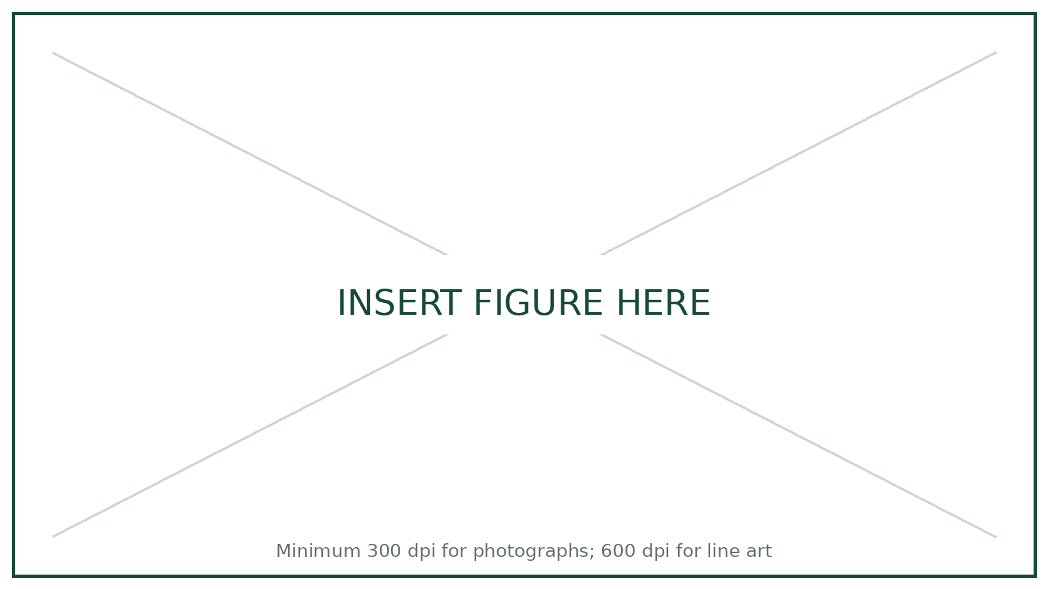
Figure 1. Example figure. Define all symbols and abbreviations in the caption. For multi-panel figures, describe panels as (a), (b), and so forth.

Table 1. Example table. Keep titles concise and place explanatory notes below the table.
Preparation Design | Mean ± SD (N) | 95% CI
Group 1 | 000.0 ± 00.0 | 000.0–000.0
Group 2 | 000.0 ± 00.0 | 000.0–000.0
Group 3 | 000.0 ± 00.0 | 000.0–000.0
Group 4 | 000.0 ± 00.0 | 000.0–000.0
Note: Define abbreviations and statistical symbols. Identify the statistical test and significance level where applicable.
Table 2. Example categorical data table.
Variable | Category | n | %
Material | A | 00 | 00.0
 | B | 00 | 00.0
Outcome | Success | 00 | 00.0
 | Failure | 00 | 00.0
3.3. Mathematical Components
Equations should be centered and numbered consecutively. Define every variable at first use.
a = b + c | (1)
The text following an equation may continue in the same paragraph. Punctuate equations as part of the sentence.
Theorem 1. State theorem-type material in a concise form and number it sequentially.
Proof. Provide the proof here and conclude with the appropriate end-of-proof symbol. □
4. Discussion
Interpret the findings in relation to the study hypothesis and prior evidence. Explain agreements and discrepancies, clinical or scientific implications, strengths, limitations, and reasonable directions for future research. Do not repeat the Results section.
5. Conclusions
State the main conclusion supported by the results. Avoid broad claims that exceed the design, sample, or measured outcomes.
6. Patents
This optional section may be included when patents result from the reported work.
Supplementary Materials
Optional. Delete this section if no supplementary material is provided. During double-blind review, remove identifying file names, links, and metadata.
Author Contributions
Required for manuscripts with more than one author. Use the CRediT taxonomy. During double-blind review, use anonymized initials (for example, A.A. and B.B.) or write “[BLINDED FOR REVIEW]”.
Funding
Required. State the funding agency and grant number, or write: “This research received no external funding.” During double-blind review, replace identifying funding details with “[BLINDED FOR REVIEW]” and provide the complete information on the separate title page.
Institutional Review Board Statement
Include when applicable; otherwise state: “Not applicable.” During double-blind review, anonymize the institution and any identifying approval details and provide the complete information on the separate title page.
Informed Consent Statement
Include when applicable; otherwise state: “Not applicable.” Obtain written consent for publication when a participant can be identified.
Data Availability Statement
Required. Describe where the data supporting the findings can be accessed, or explain any justified restrictions. During double-blind review, remove or anonymize links and repository details that could identify the authors.
Acknowledgments
Optional. Delete this section if there is nothing to acknowledge. During double-blind review, write “[BLINDED FOR REVIEW]” and provide the complete acknowledgment on the separate title page.
Generative AI Disclosure
Include only when generative AI was used substantively in the study or manuscript. Delete this section when it is not applicable. Routine grammar, spelling, punctuation, and formatting assistance does not require a declaration.
Conflicts of Interest
Required. Declare all financial and nonfinancial conflicts, or state: “The authors declare no conflicts of interest.” During double-blind review, place any identifying disclosure on the separate title page and write “[BLINDED FOR REVIEW]” here.
Abbreviations
Optional. Delete this section and the abbreviation table if no abbreviations require definition.
Abbreviation | Definition
JBOS | Journal of Biomimetics and Oral Sciences
DOI | Digital Object Identifier
CI | Confidence interval
SD | Standard deviation
References
Number references in order of appearance, including citations in tables and figure captions. Cite references in square brackets before punctuation. Include the DOI whenever available. Reference-management software is strongly recommended.
1. Author 1, A.B.; Author 2, C.D. Title of the article. Abbreviated Journal Name Year, Volume, page range. https://doi.org/xx.xxxx/xxxxx
2. Author 1, A.; Author 2, B. Title of the chapter. In Book Title, 2nd ed.; Editor 1, A.; Editor 2, B., Eds.; Publisher: City, Country, 2026; pp. 00–00.
3. Author 1, A. Book Title, 3rd ed.; Publisher: City, Country, 2026.
4. Author 1, A.B. Title of Thesis. Degree type, University, City, Country, Year.
5. Title of Website. Available online: URL (accessed on Day Month Year).
6. Author 1, A.B.; Author 2, C.D. Title of Presentation. In Proceedings of the Conference Name, City, Country, Day Month Year.
Disclaimer/Publisher’s Note: The statements, opinions, and data contained in publications are solely those of the individual authors and contributors. JBOS and its editors disclaim responsibility for injury or damage resulting from ideas, methods, instructions, or products described in the content.

