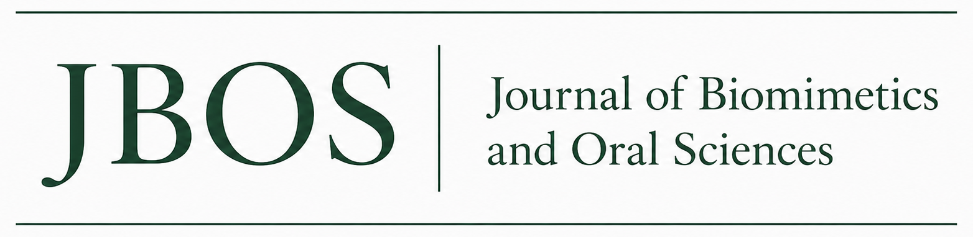
AUTHOR PUBLISHING AGREEMENT AND COPYRIGHT TRANSFER
SETUP NOTE FOR JBOS: Replace all bracketed fields before use and have this agreement reviewed by an attorney licensed in the Publisher’s jurisdiction. Delete this box after approval.
Parties and effective date. This Agreement is between the author(s) identified below and [PUBLISHER LEGAL NAME], the owner and publisher of the Journal of Biomimetics and Oral Sciences (JBOS) (the “Publisher”). The author declarations are effective upon submission. The copyright transfer is effective only if the Work is accepted and published by JBOS. If the Work is rejected or withdrawn before acceptance, the copyright transfer is void.
Manuscript title | [ENTER INFORMATION]
Corresponding author | [ENTER INFORMATION]
Email | [ENTER INFORMATION]
1. Author declarations and warranties. Each author represents and warrants that: (a) the Work is original, accurate, and has not been fabricated, falsified, plagiarized, previously published, or submitted simultaneously elsewhere, except for disclosed preprints, abstracts, theses, or conference materials permitted by JBOS policy; (b) every listed author qualifies for authorship, has reviewed and approved the final submitted version, and accepts responsibility for the Work; (c) all funding, conflicts of interest, ethical approvals, informed consent, clinical trial registration, data availability, and use of artificial intelligence have been fully and accurately disclosed; and (d) no artificial intelligence system is listed as an author, and the human authors remain responsible for all content.
2. Copyright transfer. Upon acceptance and publication, each author assigns and transfers to the Publisher all right, title, and interest in the copyright in the Work, worldwide, for the full term of copyright and any renewals or extensions, in all languages and in all formats and media now known or later developed. This includes the exclusive rights to reproduce, publish, distribute, transmit, communicate, publicly display, archive, translate, adapt, create derivative works from, license, sublicense, and otherwise use the Work, in whole or in part, and to authorize others to do so. Publisher acceptance is evidenced by publication of the Work.
3. Rights not transferred. This Agreement does not transfer ownership of patents, inventions, trademarks, raw research data, laboratory materials, or other intellectual property that exists independently of the Work. The authors retain the right to receive proper attribution and to use the underlying research and data, subject to applicable law, confidentiality duties, participant privacy, and third-party rights.
4. Author reuse rights. The Publisher grants each author a nonexclusive, royalty-free license to use the Work for personal scholarly purposes, including classroom teaching, conference presentations, a thesis or dissertation, internal institutional use, and inclusion in a later book or collection written or edited by the author, provided that the published JBOS article is properly cited and the use complies with JBOS posting and embargo policies. Commercial republication or licensing to third parties requires prior written permission from the Publisher.
5. Third-party content and permissions. The authors confirm that they own or have obtained written permission for all copyrighted or confidential material included in the Work, including figures, photographs, tables, questionnaires, scales, substantial quotations, and patient-identifiable information. The authors will provide copies of permissions and consents upon request and will accurately identify any material that is excluded from the copyright transfer.
6. Editorial and publication rights. The authors authorize JBOS to edit, format, copyedit, typeset, translate, index, abstract, correct, retract, archive, and distribute the Work. JBOS will not intentionally change the scientific meaning of the Work without consulting the corresponding author when reasonably practicable. The authors agree to cooperate with reasonable requests concerning corrections, expressions of concern, investigations, or retractions.
7. Corresponding author authority. The corresponding author confirms that all coauthors have approved the submission and this Agreement and that the corresponding author has written authority to act for them. If any author owns the copyright through an employer, institution, government, or other third party, the corresponding author must disclose that fact and obtain the required authorized signature or separate license before publication.
8. Claims and indemnification. To the extent permitted by law, the authors will indemnify and hold harmless JBOS, the Publisher, and their editors and agents from third-party claims, damages, liabilities, and reasonable legal costs arising from a material breach of the authors’ warranties or an infringement caused by material supplied by the authors, except to the extent caused by unauthorized changes or misconduct by JBOS or the Publisher.
9. Personal information. The authors authorize JBOS and the Publisher to collect, store, verify, and process author names, affiliations, email addresses, declarations, signatures, and submission records for peer review, publication, indexing, research-integrity, rights-management, and legal-compliance purposes, in accordance with the JBOS privacy policy and applicable law.
10. General terms. This Agreement is the entire agreement concerning the Work and supersedes prior oral or written statements on the same subject. Any amendment must be in writing. If a provision is unenforceable, the remaining provisions remain effective. This Agreement is governed by the laws of [STATE/COUNTRY], without regard to conflict-of-law rules, and disputes will be resolved in the courts located in [COUNTY/STATE/COUNTRY], unless applicable law requires otherwise.
SIGNATURES
Choose one method: □ Each author signs below. □ The corresponding author signs for all authors and certifies that written authority has been obtained from every coauthor.
Printed legal name | Signature / electronic signature | Date | Author / authorized representative
Corresponding author certification: I certify that the information above is accurate and that I have authority to submit the Work and accept this Agreement for all authors as indicated.
Corresponding author name | Signature / typed electronic signature | Date | Submission account email
MANDATORY ONLINE-SUBMISSION CHECKBOX TEXT
□ By checking this box and clicking “Submit,” I certify that I am the corresponding author and that I have authority from all coauthors to accept the JBOS Author Publishing Agreement. I confirm that all authors approve the manuscript and the declarations in the Agreement. I understand that the author declarations are effective immediately, while any copyright transfer becomes effective only if the manuscript is accepted and published. My typed legal name, authenticated submission account, date, and electronic action constitute my electronic signature.
Portal recordkeeping: Display a link to the complete Agreement beside an unchecked mandatory box; collect the signer’s full legal name; and retain the agreement version, account identifier, timestamp, and acceptance record. Do not pre-check the box.

